Django Tutorial

# Introduction

This is a tutorial that follows Corey Schafer’s Django series videos.

Video series: <https://www.youtube.com/watch?v=UmljXZIypDc&list=PL-osiE80TeTtoQCKZ03TU5fNfx2UY6U4p>

Youtube Channel : <https://www.youtube.com/channel/UCCezIgC97PvUuR4_gbFUs5g>

Code snippets : <https://github.com/CoreyMSchafer/code_snippets/tree/master/Django_Blog/snippets>

# Basics

## Basic Django start commands:

django-admin startproject projectname # creates new project

python manage.py runserver # runs the server

python manage.py migrate # creates a a SQlite3 database for your project.

This will create a new django project.

Making a new app within our django project.

A app basically means a part of our site . For eg. I created a blog app that represent the blog part of our website:

We create a new app with the following way:

We navigate to our project root folder and type in:

**python manage.py startapp blog**



## How do we add paths to our website :

We navigate to our newly created app ‘views.py’ module and add the following:

Think of views as a module that represents what will be shown when you use the functions from it.

from django.shortcuts import render  
from django.http import HttpResponse

def home(request):  
 return HttpResponse('<h1>Blog Home Page</h1>')  
  
def about(request):  
 return HttpResponse('<h1>About Page</

These are functions that will run when we got on home and about page (if we assign those functions to them)

Next step is making a new .py module called ‘urls’ which will contain the path and the functions to the pages.

from django.urls import path # path function from django.urls  
from . import views # '.' means from current folder  
  
urlpatterns = [  
 path('', views.home, name='blog-home'),  
 path('about/', views.about, name='home-about')  
]

The upper code basically makes our website have two more ‘pages’:

/blog/ # when it’s on blog homepage it will execute views.home function

/blog/about # when it’s on the about page it will execute views.about function

To make it work we have to add this path to the main project URL Module:

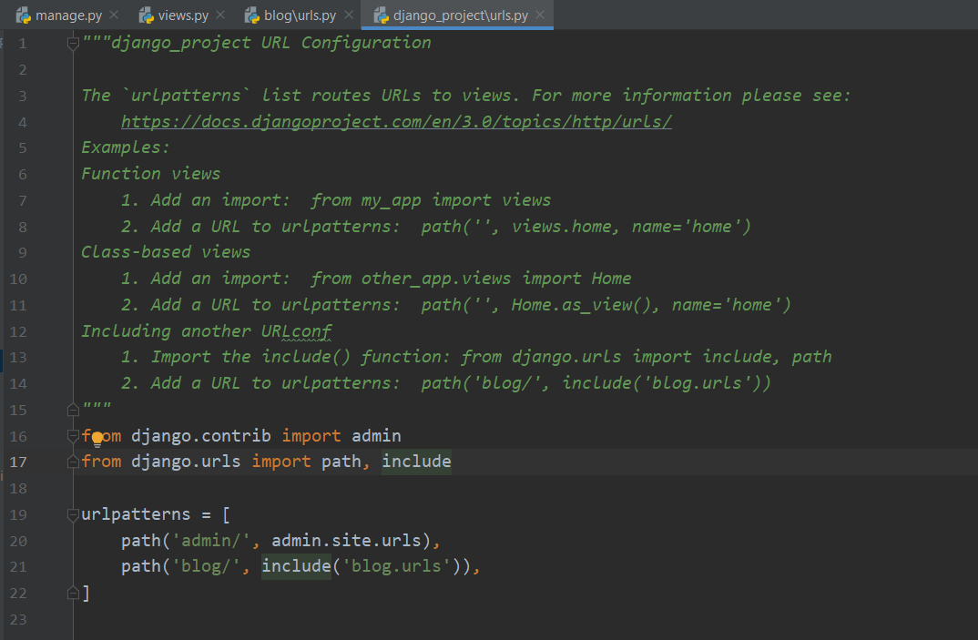

from django.contrib import admin  
from django.urls import path, include  
# The include() function basically references a python module in our case called blogs.url or in other words it MAPS it to our blogs.urls  
urlpatterns = [  
 path('admin/', admin.site.urls),  
 path('blog/', include('blog.urls')),  
]

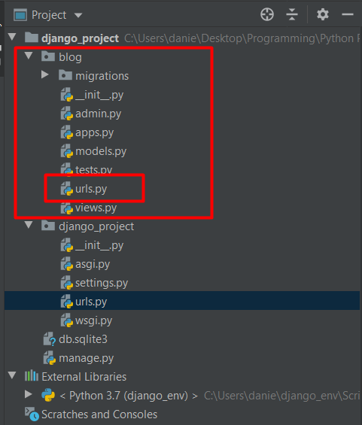

# Templates

## Adding our app config class to the main projects settings module

First we need to add our apps config class to the main project settings.py module.

myapp/apps.py , down below is our class config file

*class* BlogConfig(AppConfig):  
 name = 'blog'

Now we add this to our main project settings.py module

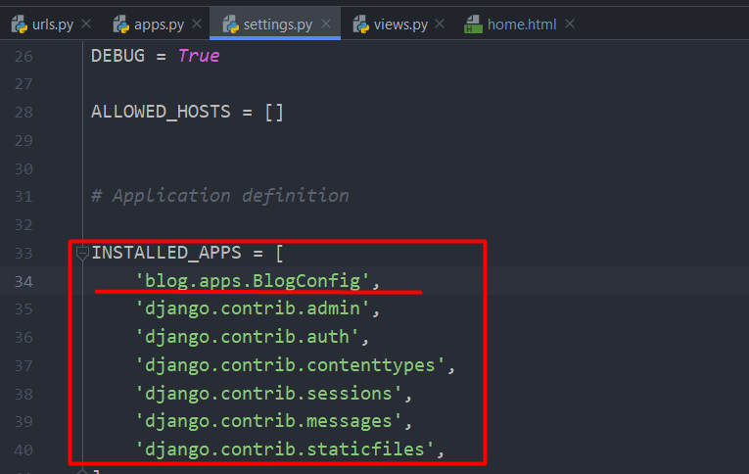

## Making templates

In order to make templates work , we have to add a templates folder inside the app we want to use the templates in our case ‘Blog’ and it should look something like this

eg. desiredapp/templates/desiredapp/

# Note : We have to make another folder in there with our apps name.

Here we are going to add the templates we want to use

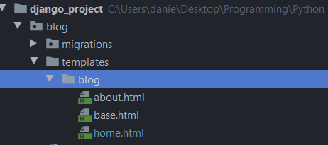

Next we go to our views.py folder and make sure that we use render() on these templates

## Django render() function:

*from* django.shortcuts *import* render

*from* django.http *import* HttpResponse

*def* about(request):  
 *return* render(request, 'blog/about.html')

# Render includes HttpResponse in it’s function

# Basically here when we the user navigates to our blog page this function will handle the request and load about.html file

## Adding dummy data and using it in our templates:

Below we add some dummy data and use it in our blog/templates/blog/home.html file

*from* django.shortcuts *import* render  
*from* django.http *import* HttpResponse  
  
posts=[  
 {  
 'author': 'Ghirasim Daniel',  
 'title': 'Blog Post 1',  
 'content': 'First post content',  
 'date_posted': '31 December, 2019'  
 },  
 {  
 'author': 'Jane Doe',  
 'title': 'Blog Post 2',  
 'content': 'Second post content',  
 'date_posted': '01 January, 2020'  
 },  
  
]  
  
*def* home(request):  
 context = {  
 'posts': posts  
 }  
 *return* render(request, 'blog/home.html', context)

Breaking it down in steps:

1. We make a list of dictionaries containing some dummy data
2. We go into our home function and make a new dictionary called context where we make a key called ‘posts’ and the value we assign to it is our posts list of dictionaries
3. Then we add the context dict as an argument to our return statement

## Accessing data in our templates .html files:

This is how our home.html file looks:

<!DOCTYPE html>  
<html>  
<head>  
 <title>Title</title>  
</head>  
<body>  
 {% for post in posts%}  
 <h1>{{post.title}}</h1>  
 <p>By {{post.author}} on {{post.date_posted}}</p>  
 <p>{{post.content}}</p>  
 {% endfor %}  
</body>  
</html>

### Code blocks in Django:

Code blocks in Django are represented like this :

{% %} – This means we are writing a code in the HTML file

### FOR LOOP in Django:

A Django for loop looks like this:

{% for post in posts%}

{% endfor %}

### VARIABLES in Django:

<h1>{{post.title}}</h1>

The double curly braces means that we want to access a variable

### IF ELSE statements in Django:

<head>  
 {% if title %}  
 <title>Django blog - {{ title }}</title>  
 {% else %}  
 <title>Django Blog</title>  
 {% endif %}  
</head>

We define title in our views.py:

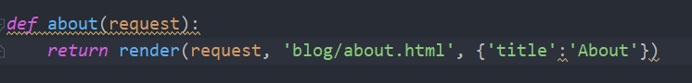

With the IF ELSE statement we say:

If we have a title print ‘Django Blog – {title}’ else print ‘Django Blog’

And it will look like this if we have a title:



and if we don’t have one:



## Template Inheritance - Base Template – Making our life easier

Making a base template helps us reduce the amount of code we have to write . We can make a base.html file from which our other .html **will inherit from** so if we modify the base.html file the other ones will automatically get modified.

We add to this base.html file all the things that are going to be constant troughout all of our .html files for eg:

<head>  
 {% if title %}  
 <title>Django blog - {{ title }}</title>  
 {% else %}  
 <title>Django Blog</title>  
 {% endif %}  
</head>

We want this if statement for all of our website.

### How does a base template work

This is how our base.html looks after some editing:

<!DOCTYPE HTML PUBLIC "-//W3C//DTD HTML 4.01 Transitional//EN"  
 "http://www.w3.org/TR/html4/loose.dtd">  
<html>  
<head>  
 {% if title %}  
 <title>Django blog - {{ title }}</title>  
 {% else %}  
 <title>Django Blog</title>  
 {% endif %}  
</head>  
<body>  
 {% block content %}{% endblock %}  
</body>  
</html>

Between the block content code we are going to set each or .html files information.

for eg. home.html will look like this:

{% extends 'blog/base.html' %}   
{% block content %}  
 {% for post in posts%}  
 <h1>{{post.title}}</h1>  
 <p>By {{post.author}} on {{post.date_posted}}</p>  
 <p>{{post.content}}</p>  
 {% endfor %}  
{% endblock content %}

We deleted everything that is found in base.html and are that we are left with is the actual code we want to run on the page.

{% extends 'blog/base.html' %}

This tells our home.html file that it **extends** base.html and after that we add:

{% block content %}  
 # We add our home.html code here  
{% endblock content

{% block content %} this refers to the CONTENT BLOCK we can have several blocks in a template file.

like {% block posts %} {% block pictures %} (have to verify this).

This is how our about page looks.

{% extends 'blog/base.html' %}  
{% block content %}  
 <h1>About Page!</h1>  
{% endblock content %}

Notice we reduced the code drastically by using template inheritance.

## Bootstrap

Bootstrap is a extremely popular library which makes it easy to add some nice styles to your website.

Basically we drag and drop the Bootstrap starter template into our base.html file . (It does some magic and it works).

#### Starter template:

<!doctype html>

<html lang="en">

<head>

<!-- Required meta tags -->

<meta charset="utf-8">

<meta name="viewport" content="width=device-width, initial-scale=1, shrink-to-fit=no">

<!-- Bootstrap CSS -->

<link rel="stylesheet" href="https://stackpath.bootstrapcdn.com/bootstrap/4.3.1/css/bootstrap.min.css" integrity="sha384-ggOyR0iXCbMQv3Xipma34MD+dH/1fQ784/j6cY/iJTQUOhcWr7x9JvoRxT2MZw1T" crossorigin="anonymous">

<title>Hello, world!</title>

</head>

<body>

<h1>Hello, world!</h1>

<!-- Optional JavaScript -->

<!-- jQuery first, then Popper.js, then Bootstrap JS -->

<script src="https://code.jquery.com/jquery-3.3.1.slim.min.js" integrity="sha384-q8i/X+965DzO0rT7abK41JStQIAqVgRVzpbzo5smXKp4YfRvH+8abtTE1Pi6jizo" crossorigin="anonymous"></script>

<script src="https://cdnjs.cloudflare.com/ajax/libs/popper.js/1.14.7/umd/popper.min.js" integrity="sha384-UO2eT0CpHqdSJQ6hJty5KVphtPhzWj9WO1clHTMGa3JDZwrnQq4sF86dIHNDz0W1" crossorigin="anonymous"></script>

<script src="https://stackpath.bootstrapcdn.com/bootstrap/4.3.1/js/bootstrap.min.js" integrity="sha384-JjSmVgyd0p3pXB1rRibZUAYoIIy6OrQ6VrjIEaFf/nJGzIxFDsf4x0xIM+B07jRM" crossorigin="anonymous"></script>

</body>

</html>

#### Adding bootstrap to our base.html

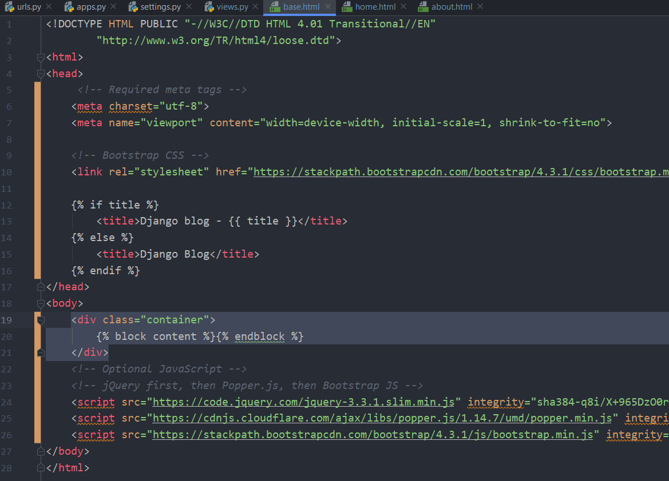

Notice we added our block content between <div> tags . I don’t really know the magic behind this but after the first div tag we add a class called ‘class=”container”’ (This gives our content some good padding and spacing)

After adding this I noticed the text moves slightly to the right.

## Adding a navigation bar

This is the template for a navigation bar:Top of Form

Bottom of Form

Top of Form

Bottom of Form

|  |  |
| --- | --- |
|  | <header class="site-header"> |
|  | <nav class="navbar navbar-expand-md navbar-dark bg-steel fixed-top"> |
|  | <div class="container"> |
|  | <a class="navbar-brand mr-4" href="/">Django Blog</a> |
|  | <button class="navbar-toggler" type="button" data-toggle="collapse" data-target="#navbarToggle" aria-controls="navbarToggle" aria-expanded="false" aria-label="Toggle navigation"> |
|  | <span class="navbar-toggler-icon"></span> |
|  | </button> |
|  | <div class="collapse navbar-collapse" id="navbarToggle"> |
|  | <div class="navbar-nav mr-auto"> |
|  | <a class="nav-item nav-link" href="/">Home</a> |
|  | <a class="nav-item nav-link" href="/about">About</a> |
|  | </div> |
|  | <!-- Navbar Right Side --> |
|  | <div class="navbar-nav"> |
|  | <a class="nav-item nav-link" href="#">Login</a> |
|  | <a class="nav-item nav-link" href="#">Register</a> |
|  | </div> |
|  | </div> |
|  | </div> |
|  | </nav> |
|  | </header> |

We are going to add this to the base.html file , we are going this between the body tags of our base.html

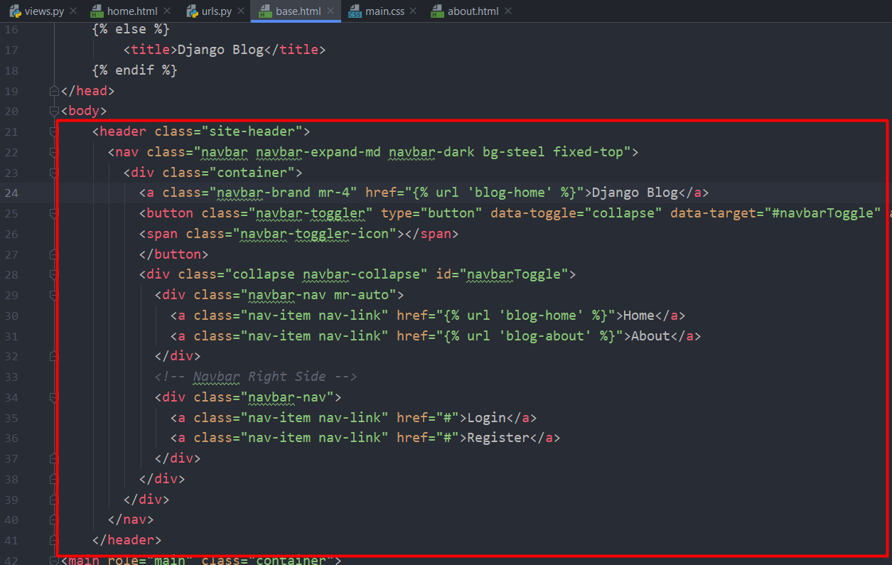

## Content Block Styling – Adding a main section for content block styling.

We are going to replace our content block section of base.html with some prewritten code to make it look nicer :

|  |
| --- |
| <main role="main" class="container"> |
|  | <div class="row"> |
|  | <div class="col-md-8"> |
|  | {% block content %}{% endblock %} |
|  | </div> |
|  | <div class="col-md-4"> |
|  | <div class="content-section"> |
|  | <h3>Our Sidebar</h3> |
|  | <p class='text-muted'>You can put any information here you'd like. |
|  | <ul class="list-group"> |
|  | <li class="list-group-item list-group-item-light">Latest Posts</li> |
|  | <li class="list-group-item list-group-item-light">Announcements</li> |
|  | <li class="list-group-item list-group-item-light">Calendars</li> |
|  | <li class="list-group-item list-group-item-light">etc</li> |
|  | </ul> |
|  | </p> |
|  | </div> |
|  | </div> |
|  | </div> |
|  | </main> |

Our newly modified base.html should look something like this

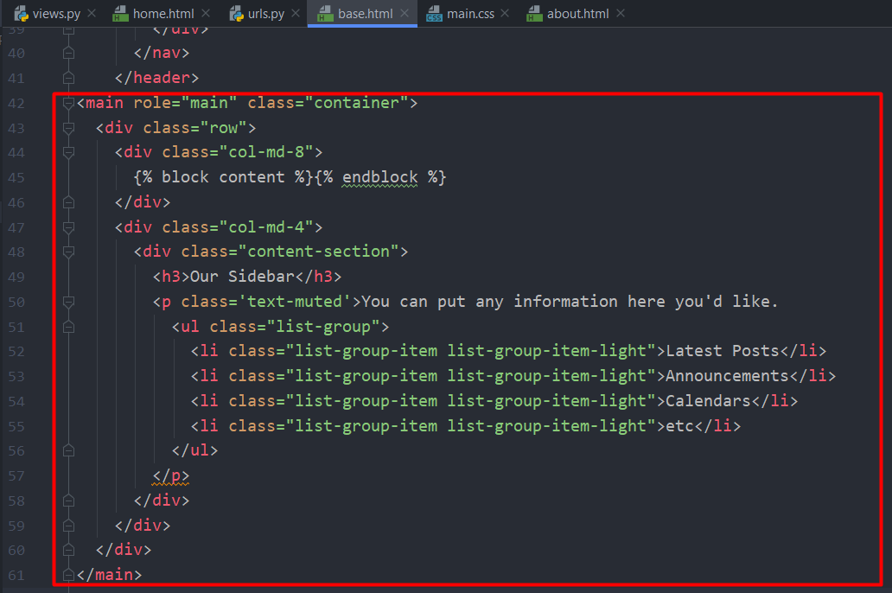

Notice we added {% block content %} {% endblock %} in a <div> tag

## Adding CSS files

In django , static files like .CSS and .JAVASCRIPT have to be located in a static directory within our app

eg. myapp/static/myapp/

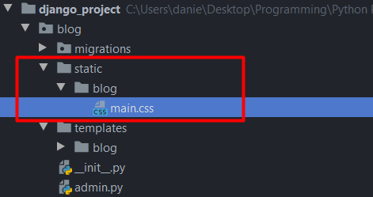

The main.css file looks like this:

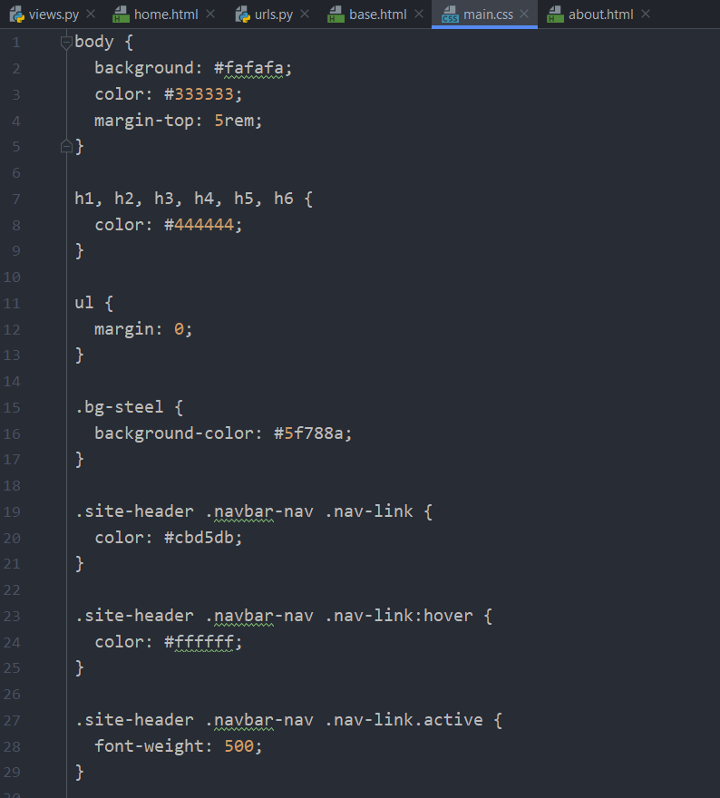

### How to include .CSS file

1. We load in our .CSS file from our static directory by adding

{% load static %} to the top of our base.HTML file.

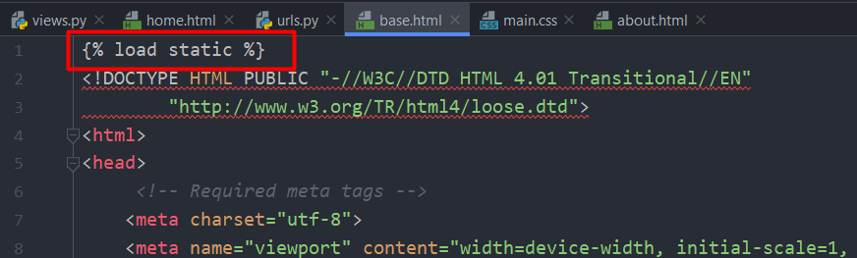

1. We add the next line of code:

<link rel="stylesheet" type="text/css" href="{% static 'blog/main.css' %}">

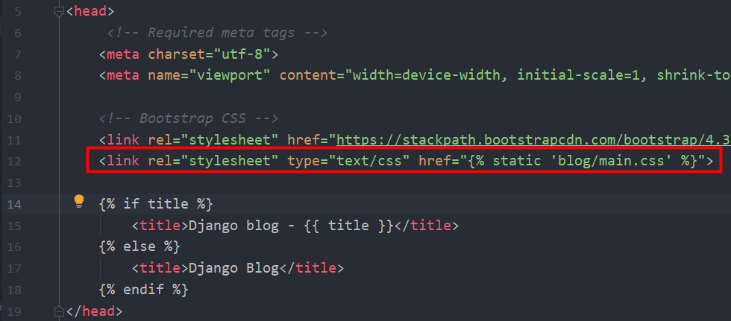

This basically gives style to our base.html file

### Styling the articles with our new .CSS file

Our new .CSS file has styling for each article posted on our blog we just need to add the functionality to our page.

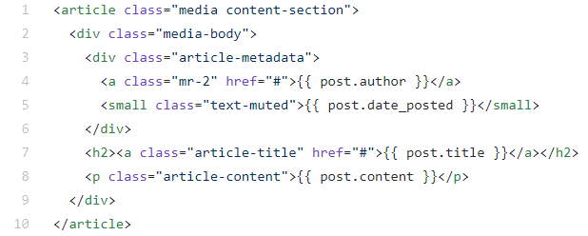

We are going to add this line within our for loop. Note that it has the second part of our for loop code already inserted

{% extends 'blog/base.html' %}  
{% block content %}  
 {% for post in posts%}  
 <article class="media content-section">  
 <div class="media-body">  
 <div class="article-metadata">  
 <a class="mr-2" href="#">{{ post.author }}</a>  
 <small class="text-muted">{{ post.date_posted }}</small>  
 </div>  
 <h2><a class="article-title" href="#">{{ post.title }}</a></h2>  
 <p class="article-content">{{ post.content }}</p>  
 </div>  
 </article>  
 {% endfor %}  
{% endblock content %}

## Making our templates more flexible

We are going to edit some “href=” variables in the navigation part of our base.html code in order to make site navigation much easer if we change the paths of our website in the future.

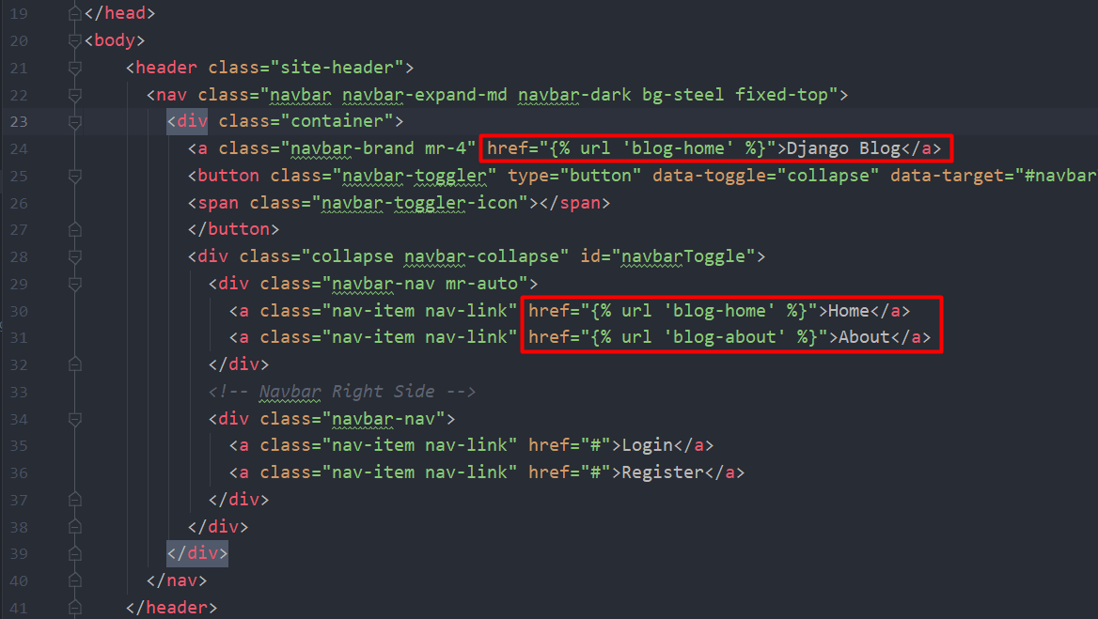

We modified the “href” to link us to the page name not the page path so in the future if we want to move Django blog to a different path we won’t have to manually modify the path because we give it it’s name. Example below:

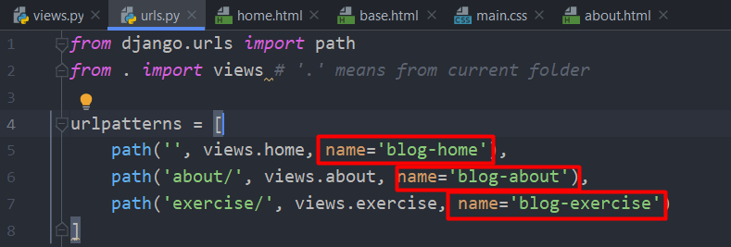

So basically we are referecing the name of the page not the path. Django will handle the hardwork.

## Adding a HYPER-LINK (Clickable thingie magic)

So if you want to add a new Hyperlink to your website like : Login , Register etc. Just do the following.

<a class="nav-item nav-link" href="#">Login</a>  
<a class="nav-item nav-link" href="#">Register</a>  
<a class="nav-item nav-link" href="https://www.youtube.com/watch?v=dQw4w9WgXcQ">Magic</a>

I don’t know exactly how it works , it might be some Bootstrap or CSS magic. But basically you add another <a> </a> tag (which is a hyperlink tag according to the interwebs) and add your stuff.

On the HREF I added a link to a very special youtube video.

# Creating the database

In order to advance we have to create a database by writing the following commands into the CMD prompt or terminal.

python manage.py migrate

This command basically creates an SQlite3 database for us (more on that later)

# Admin Page

## Creating an admin user

First we have to create an admin user using CMD prompt or terminal.

python manage.py createsuperuser

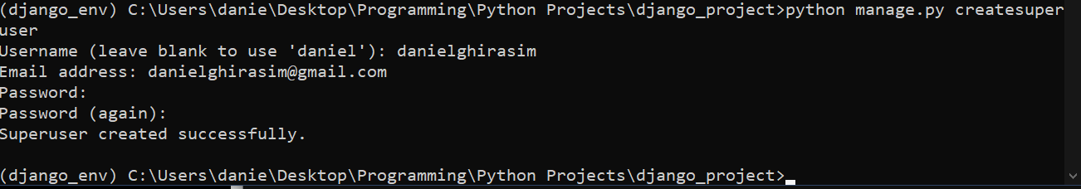

After this you can access the admin page by going to:

localhost:8000/admin/ - And typing in the admin account you just created

# Working with Databases in Django

## Some information

Django has it’s own built in ORM (Object Relational Mapper) which basically allows you to access the database data in an object oriented manner.

What’s cool about this is that it allows you to use different databases without changing your code

Django supported databases:

* [PostgreSQL](https://docs.djangoproject.com/en/3.0/ref/databases/#postgresql-notes)
* [MariaDB](https://docs.djangoproject.com/en/3.0/ref/databases/#mariadb-notes)
* [MySQL](https://docs.djangoproject.com/en/3.0/ref/databases/#mysql-notes)
* [Oracle](https://docs.djangoproject.com/en/3.0/ref/databases/#oracle-notes)
* [SQLite](https://docs.djangoproject.com/en/3.0/ref/databases/#sqlite-notes)

We can represent our databases as classes but in Django we call the **models .** We can have a look at our models.py module here :

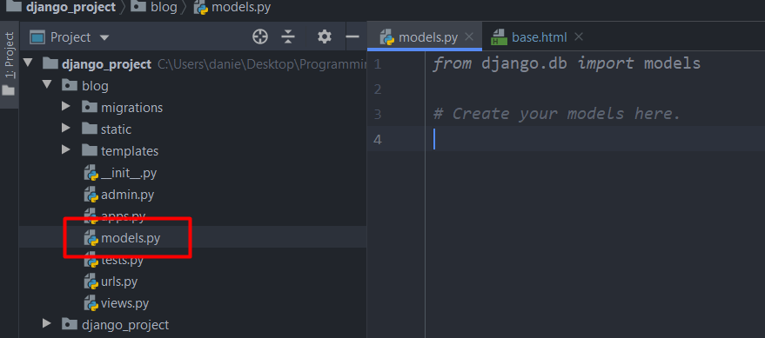

Here we are going to make a post model (basically a post class) which will inherit from django.Model class

**Each class is going to be it’s own table in the DATABASE and each attribute will be a different field in the database.**

## Adding databases

We refer to databases as models in Django .

Creating a database is as easy as adding a new class in models.py that inherits from django.models and it should look something like this

*from* django.db *import* models  
*from* django.utils *import* timezone  
  
*# Create your models here.*"""Each class is going to be a table in our database"""  
*class* Post(models.Model):  
 *"""Each attribute is a field in the database"""* title = models.CharField(max_length=100)

content = models.TextField()  
 date_posted = models.DateTimeField(default=timezone.now)

#max_lenght = length of charfield

# date_posted = models.DateTimeField(auto_now=*True*) auto_now = True sets our date_posted to the time it was posted but we are going to use the upper example because we want to store the timezone aswell . timezone.now is a function but we didn’t put () yet because we don’t want to execute it just yet.

We are also going to create a user attribute but since we already have a user database we are going to import that in this file.

Users and Posts are going to have a relationship , specifically this **will be called a 1 to many relationship** because a User can have multiple post and a post can’t have multiple users (here atleast) and to do this in django we use a **Foreign Key**

We are going to import Users since it already has a database created by django . The import location is :

*from* django.contrib.auth.models *import* User

After that we are going to add:

author = models.ForeignKey(User, on_delete=models.CASCADE())

# on_delete = models.CASCADE() means that when you delete a USER it will delete all his posts.

In the end our models.py should look something like this” *from* django.db *import* models  
*from* django.utils *import* timezone  
*from* django.contrib.auth.models *import* User  
  
*# Create your models here.*"""Each class is going to be a table in our database"""  
*class* Post(models.Model):  
 *"""Each attribute is a field in the database"""* title = models.CharField(max_length=100)  
 content = models.TextField()  
 date_posted = models.DateTimeField(default=timezone.now)  
 author = models.ForeignKey(User, on_delete=models.CASCADE)

After all this to make the changes we have to make migrations (Update the database).

We do this by entering python manage.py makemigrations into the terminal or command prompt and it should look something like this :

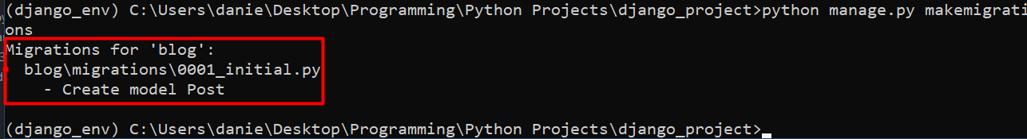

## SQL Code command (views the actualy SQL CODE)

To view the actual SQL code that is run we have to type :

python manage.py sqlmigrate blog 0001

It should look something like this:

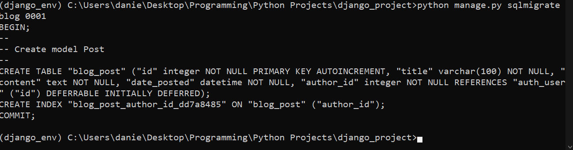

Django actually takes the information we entered and runs the command in SQlite 3 to make a table and field for our class , which makes our life much easier.

## Using CMD prompt to access databases

To access various information about our databases we can enter the next line into the command prompt:

**python manage.py shell**

**to exit the shell type : exit()**

This will open a python shell in our command prompt where we can enter commands:

from djang.contrib.auth.models import User (this imports our user database)

**User.objects.all() – Will list the contents of our User database**

**User.objects.first() – or last() will list the first or last entry in our database**

**User.objects.filter(username=’user’) – will filter for entered username**

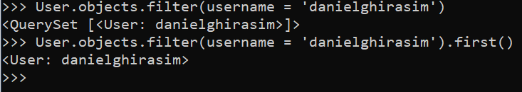

We can also use:

User.objects.filter(username=’danielghirasim) and it will give us a querry set . If we add first() to the end of the function it will give us the first username

We can set the upper mentioned function to a variable and then we can access more information from it ex:



Some commands we can run on this:

user.id – shows id

user.pk – shows primary key (id)

## Creating a post from Terminal

First we import our Post class that we just made .

from blog.models import Post

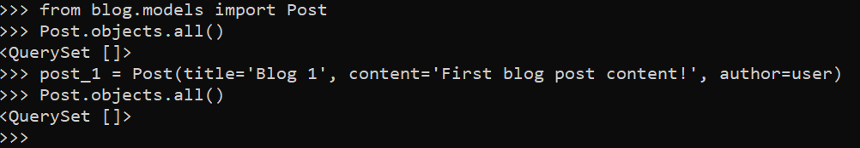

So in the picture above we created a post . Notice that we haven’t filled anything to our date_created field but since we set it to timezone.now, this should automatically get the time we created post_1.

After that we querry the Post database again and we can see we that the querry is still empty, this is because we have to migrate our post_1 to the database by using the following command.



After that we querry the DB again and we should see that it was added.



### Getting more descriptive querries

To get more descriptive querries we have to add some code to our Post class we created before.

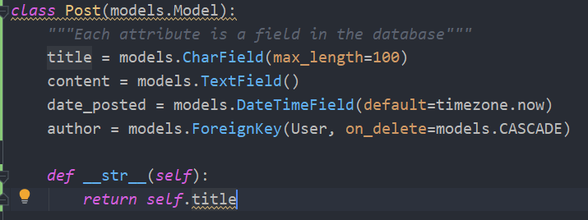

This dunder method basically applies the __str__ method to the Post class (self = Post class) and returns self.title

So it basically returns a string of Post.title.

After that we have to restart the shell by using exit() and reentering the imports and the commands and the querry should look like this

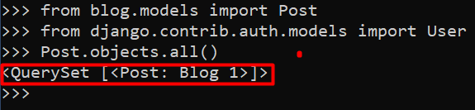

To acess all of our Post content we are going to set the post to a variable:

**post = Post.objects.first() – gives us the first post**

**post.content – prints content**

**post.title – prints title**

**post.author – prints author**

We can even access author data from here with the example below.

**post.author.email – this is gonna print the authors email so we don’t have to run a separate command for that aswell.**

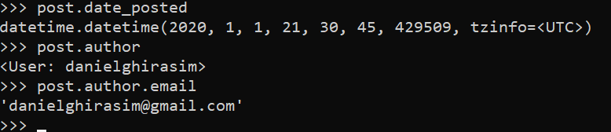

### Getting all USER posts with a simple command

We can get all the posts that a user posted by doing the following:

user = User.objects.get(username=’username’)

user.post_set.all() 🡪 This command will show all the posts created by the user we choose

We can also create posts while we have this user as a variable by using the following command line:



Using this method we don’t have to run the save function anymore and we don’t have to exit out of the shell. Also notice we didn’t enter the user in the function parameters since we already have the user defined.

## Connecting our Post database to our website

Here we are going to replace our dummy data with our data within our database.

We are going to do this the following way:

1. We are going to import our Post database into our views.py module

*from* .models *import* Post

*def* home(request):  
 context = {  
 'posts': Post.objects.all()  
 }  
 *return* render(request, 'blog/home.html', context)

As long as our dummy data’s dictionary keys were the same as our database fields everything should work fine without having to modify anything in our home.html file . If they are different we just have to go into our home.html and modify the FOR LOOP.

Aaaaaand it works !!!

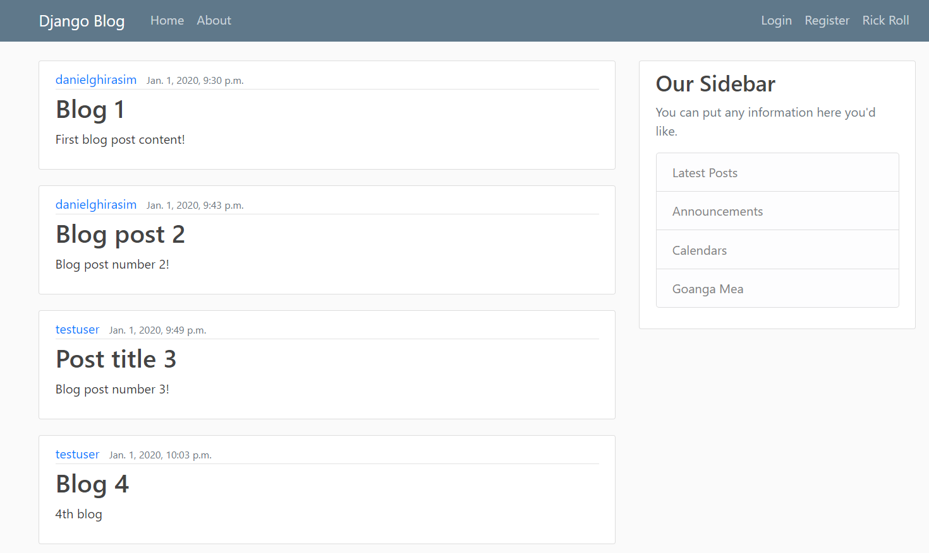

## Changing how our Date Time looks

We are going to change how our date time looks to make it a little bit neater.

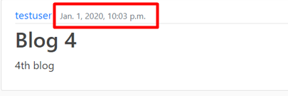

To do this we have to go to our home.html file and modify a bit of code by using Django documentation of dates as a reference (<https://docs.djangoproject.com/en/3.0/ref/templates/builtins/#date>):

The code should look like this:

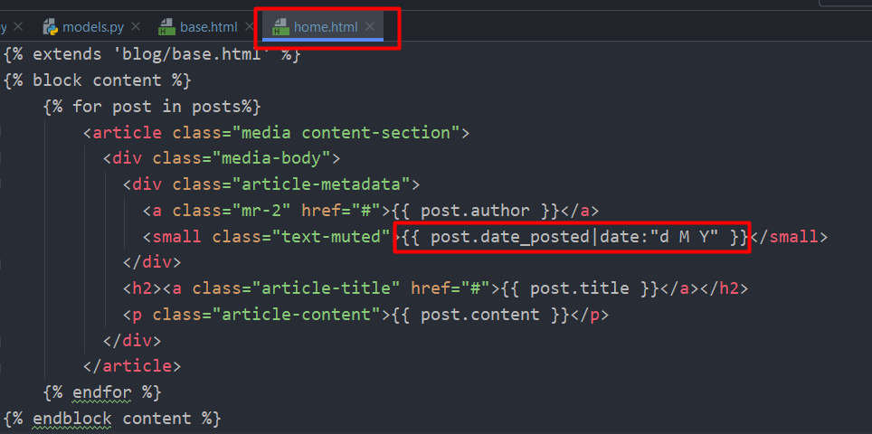

After we modified it , it should look something like this :

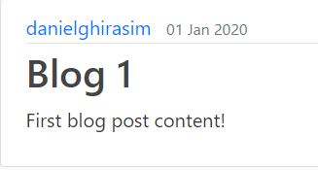

## Registering Databases (models) to the admin page

So when we enter the admin page we want to register our Post database in order to modify it . This is a very simple process thanks to Django is as easy as going into the admin.py module and entering a few lines of code.

*from* django.contrib *import* admin  
*from* .models *import* Post  
  
admin.site.register(Post)

This will add an editable Post section to our admin page and it’s freakin’ cool how easy it is.

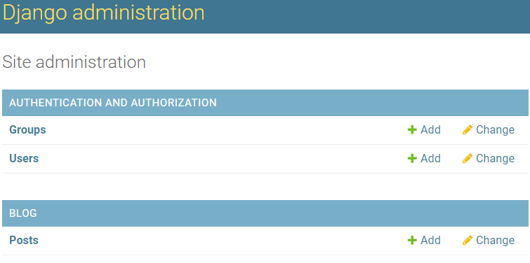

The editing section looks like this:

s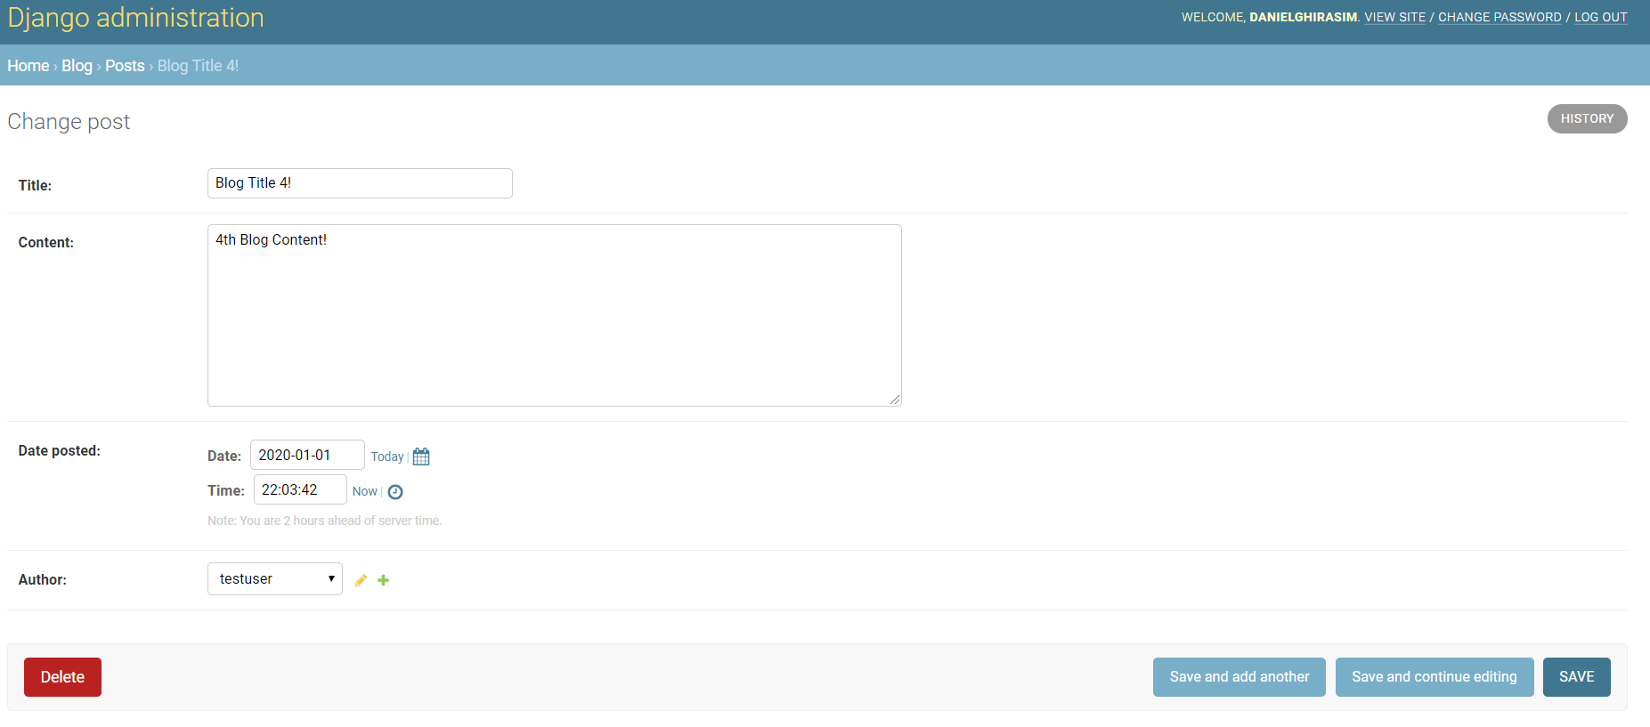

# User Registration

In this part we are going to learn how to make forms and validate user input to make a user registration page.

The best thing to do is to create a new app inside of our project for this.

## Making a new app for users

So we are going to go into our terminal and write:

Python manage.py startapp users

This will create a users app for us and we have to put the config class into our main folders settings.py.

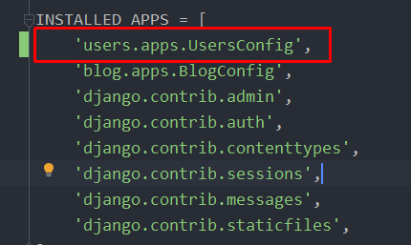

**Don’t forget the comma since this is a list.**

## Adding a new path for register.html

We are going to add path to our register page in our main directory in the urls.py file but this time we are going to directly import the views.py module from our newly made app

*from* django.contrib *import* admin  
*from* django.urls *import* path, include  
*from* users *import* views *as* user_views  
  
urlpatterns = [  
 path('admin/', admin.site.urls),  
 path('register/', user_views.register, name='register'),  
 path('', include('blog.urls')),  
]

This tells the website that whenever somebody accesses mysite.com/register, the website needs to run our register function from users.views

## Creating a submission form

Luckily we don’t have to reinvent the wheel. Django already has a registration form premade for us with all the bells and whistles regarding security.

We are going to navigate to our users/views.py and do the following

*from* django.shortcuts *import* render  
*from* django.contrib.auth.forms *import* UserCreationForm  
*# UserCreationForm is a premade Django creation form class.  
  
def* register(request):  
 form = UserCreationForm() *# We are gonna make an instance for the class we just imported  
 return* render(request, 'users/register.html', {'form': form})

We made an instance of the UserCreationForm class and assigned it to a variable inside our register function.

And within the function we make a dictionary with a key called ‘form’ and the value is the instance of our class.

.

Next we have to take care of our 'users/register.html' which is not yet defined.

## Creating a user template

We are going to do the same thing as we did in our blog app . We are going to a create a folder within our Users app called template and within that folder another folder called users (this is the Django convetion). It should look something like this:

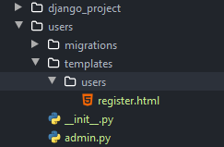

Next we are going to work on register.html

## Register.html

Here we are going to edit our register.html.

In order to make our lives easier we are going to copy our code from the about.html (from blog app) which extends our base.html

A nice thing about Django framework is that we can use the base.html file from other apps as well like we are going to do below.

{% extends 'blog/base.html' %}  
{% block content %}  
 <h1>About Page!</h1>  
{% endblock content %}

We are going to edit this piece of code until we get what we desire from the register.html page.

Our modified code should look something like this

{% extends 'blog/base.html' %}  
{% block content %}  
 <div class="content-section">  
 <form method="POST"> # We will come back to this later  
 {% csrf_token %}  
 <fieldset class="form-group">  
 <legend class="border-bottom mb-4">Join Today</legend>  
 {{ form }}  
 </fieldset>  
 <div class="form-grou">  
 <button class="btn btn-outline-info" type="submit" >Sign Up</button>  
 </div>  
 </form>  
 <div class="border-top pt-3">  
 <small class="text-muted">  
 Already Have an Account? <a class="ml-2" href="#"> Sign in </a>  
 </small>  
 </div>  
 </div>  
{% endblock content %}

### {% csrf_token %} - Security

This is a Django security must. Basically this line of code prevents us from some sort of online attack that can be run on registration pages (don’t really have details on it). Without this our form will not work.

### Register page code meaning

The classes you see in each tag come from **BOOTSTRAP** it’s pretty cool (it basically magic autoformats your stuff.)

{{ form }} – This makes our form look like this:

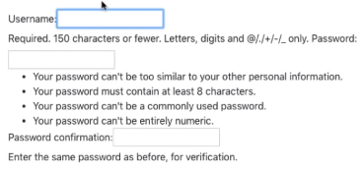

Our Sign-Up and already have an account? Button look like this:

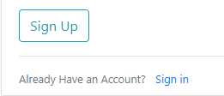

And our overall register page looks like this (for now):

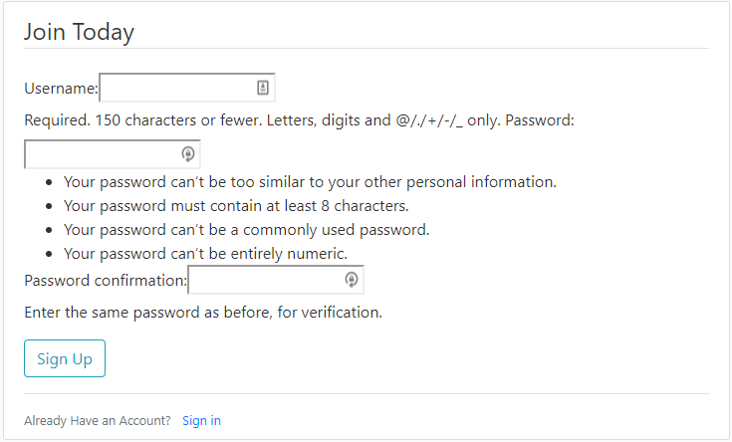

### Adding register.html to our base.html as a ref

Next we will add our register.html url to the base.html file so whenever we click on the register button on our homepage it will redirect us to the register.html website.

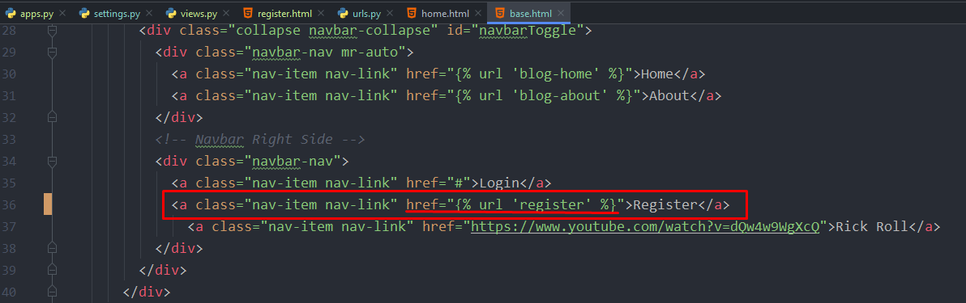

This is as simple as adding {% url ‘register.html’ %} at href.

### Explaining register.html

Register.html

{% extends 'blog/base.html' %}  
{% block content %}  
 **<**div class="content-section"**>  
 <**form method="POST"**>** {% csrf_token %}  
 **<**fieldset class="form-group"**>  
 <**legend class="border-bottom mb-4"**>**Join Today**</**legend**>** {{ form.as_p }}  
 **</**fieldset**>  
 <**div class="form-group"**>  
 <**button class="btn btn-outline-info" type="submit" **>**Sign Up**</**button**>  
 </**div**>  
 </**form**>  
 <**div class="border-top pt-3"**>  
 <**small class="text-muted"**>** Already Have an Account? **<**a class="ml-2" href="#"**>** Sign in **</**a**>  
 </**small**>  
 </**div**>  
 </**div**>**{% endblock content %}

Explained:

1. We extend this from our base.html file . A cool thing in Django is that we can extend from other apps like we did here, we extended from our blog/base.html.
2. After that we are going make a new div with some custom bootstrap classes. Within that div we are going to make a <form> tag with method=’POST’. This refers to the http.post method which is a way of sending information to the website. (request is when we get information, post is when we send information)
3. Next we add our csrf_token which is a django security measure for each form. Our website will not run without this.
4. We add a fieldset tag, add some bootstrap formatting to it then we pass in our form variable. Notice we added {{ form.as_p }} this basically formats our fieldset a bit nicer. (We will further improve on this with crispy forms later on)

## Creating a register view function

Here we are going to create a function that will render us a user registration page. We don’t have to reinvent the wheel here so we are going to use a built-in form from Django.

from django.shortcuts import render  
from django.contrib.auth.forms import UserCreationForm  
*# UserCreationForm is a premade Django creation form class.*def register**(**request**)**:  
 form = UserCreationForm**()** *# We are gonna make an instance for the class we just imported* return render**(**request, **'users/register.html'**, **{'form'**: form**})**

We don’t have our register.html template created yet and also we are going to pass in our form to a dictionary so we can access it within our register.html.

Now we are going to make the register.html template. As by Django convention we are going to create the following directory tree:

Users>templates>users>register.html

## Setting the path to our register page

We could have created another urls.py module in our Users app like we did with our blog and then include() in the Django_project/urls.py but we are going to do it another way for flexibility.

We are going to navigate to our Django_project/urls.py and import our users/views.py

from users import views as user_views

We imported this as user_views in order to avoid future conflicts if we import another views module.

After this we are going to include this in our urlpatterns list.

urlpatterns = **[** path**('admin/'**, admin.site.urls**)**,  
 **path('register/', user_views.register, name='register'),**  
 path**(''**, include**('blog.urls'))**,  
**]**

## Taking a look at our current register() function

def register**(**request**)**:  
 form = UserCreationForm**()** *# We are gonna make an instance for the class we just imported* return render**(**request, **'users/register.html'**, **{'form'**: form**})**

So the problem with our current register method is that every time someone makes a request to our register page they will get a empty UserCreationForm and when they press sign-up nothing happens.

There are different type of http requests we can have, the most common we used until now are get() request which just “get” the information from the website. The one we are going to use now is the POST request . Remember we typed method=POST in our register.html page this means that the method we want to use for those fields is post and since we didn’t specify where we want to post that data, it actually just posts it back to this route.

So what are we going to do now is add some conditional statements so when we receive a post request it validates that data and if it’s a get request then it displays our register page.

if request.method == **'POST'**:  
 form = UserCreationForm**(**request.POST**)**else:  
 form = UserCreationForm**()** *# We are gonna make an instance for the class we just imported*return render**(**request, **'users/register.html'**, **{'form'**: form**})**

So once again. If we get a POST request then it instantiates a UserCreationForm with that post data and if we get any other type of request it just instantiates an empty form. The next step is validating our usercreationform

## Validating our user creating form

def register**(**request**)**:  
 if request.method == **'POST'**:  
 form = UserCreationForm**(**request.POST**)** if form.is_valid**()**:  
 username = form.cleaned_data.get**('username')**

**# more to add** else:  
 form = UserCreationForm**()** *# We are gonna make an instance for the class we just imported* return render**(**request, **'users/register.html'**, **{'form'**: form**})**

In order to validate our user data we are going to use the is_valid() function which basically tells us if our form is valid then we are going to grab that data. To do this we simply type username = form.cleaned_data.get(‘username’) and our validated form data will be in form.cleaned_data DICTIONARY and this will convert the data nicely to python for us.

## Flash messages

Flash messages are printed out messages in our website that tells us if something was successful, unsuccessful etc.

First thing is to import messages

from django.contrib import messages

Types of flash messages:

Messages.debug

Messages.info

Messages.success

Messages.warning

Messages.error

Since we are going to display a message if our form is valid we are going to use the success message

def register**(**request**)**:  
 if request.method == **'POST'**:  
 form = UserCreationForm**(**request.POST**)** if form.is_valid**()**:  
 username = form.cleaned_data.get**('username')** messages.success**(**request, **f'Account {**username**} created succesfully.')  
 # more to add** else:  
 form = UserCreationForm**()** *# We are gonna make an instance for the class we just imported* return render**(**request, **'users/register.html'**, **{'form'**: form**})**

Our messages take in a request parameter and we can also add a message.

## Redirect function

If our uservalidation went ok we are going to redirect our users to the homepage. To do this we want to import the redirect function from Django by :

from django.shortcuts import render, redirect

def register**(**request**)**:  
 if request.method == **'POST'**:  
 form = UserCreationForm**(**request.POST**)** if form.is_valid**()**:  
 username = form.cleaned_data.get**('username')** messages.success**(**request, **f'Account {**username**} created succesfully.')** return redirect**('blog-home')** else:  
 form = UserCreationForm**()** *# We are gonna make an instance for the class we just imported* return render**(**request, **'users/register.html'**, **{'form'**: form**})**

This should all work but we have to update our template to work with our flash messages. We are going to add this to our base template so any flash messages appear on every page that inherits from base.

## Adding flash messages to our base.html

In order to display the flash messages we have to add the functionality to our base.html.

**<**main role="main" class="container"**>  
 <**div class="row"**>  
 <**div class="col-md-8"**>** {% if messages %}  
 {% for message in messages %}  
 **<**div class="alert alert-{{ message.tags }}"**>** {{ message }}  
 **</**div**>** {% endfor %}  
 {% endif %}  
 {% block content %}{% endblock %}  
 **</**div**>  
 <**div class="col-md-4"**>  
 <**div class="content-section"**>  
 <**h3**>**Our Sidebar**</**h3**>**

A good place to place these flash messages are just above our content. A nice thing about Django that the message names coincide with bootstrap message formats. Se we can type the following:

**<**div class="alert alert-{{ message.tags }}"**>**

And bootstrap will automatically recognize it if it’s a success or failure message.

This is how a success method looks with BOOTSTRAP formatting.

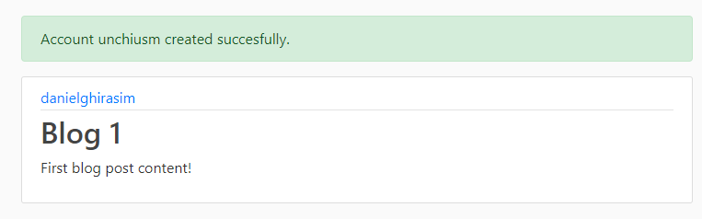

Notice we got redirected back to the homepage with a neat little message.

We didn’t actually create a new user yet we are going to that below. Here we just tested if our uservalidation works and we know that our forms are validating correctly.

## Saving the user if the form validates

Next we want to save the form if the data validates.

Saving the user it’s just as simply as adding:

Form.save() # this will automatically hash the password for us and all the other background stuff.

def register**(**request**)**:  
 if request.method == **'POST'**:  
 form = UserCreationForm**(**request.POST**)** if form.is_valid**()**:  
 form.save**()** username = form.cleaned_data.get**('username')** messages.success**(**request, **f'Account {**username**} created succesfully.')** return redirect**('blog-home')** else:  
 form = UserCreationForm**()** *# We are gonna make an instance for the class we just imported* return render**(**request, **'users/register.html'**, **{'form'**: form**})**

And now the user was created. We can check in the admin panel too.

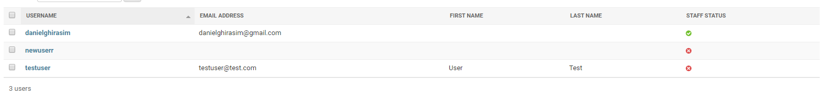

## Adding E-mail field to our registration field

If we go to our current register.html we can see that we print out all the forms as one:

**<**fieldset class="form-group"**>  
 <**legend class="border-bottom mb-4"**>**Join Today**</**legend**>** {{ form.as_p }} # We print out as one  
**</**fieldset**>**

So how do we add another field to this?

To do this we are going to need to create a new form that inherits from our UserCreationForm. Next we are going to create a new file in our Users directory called forms.py

### Forms.py – explained

from django import forms  
from django.contrib.auth.models import User  
from django.contrib.auth.forms import UserCreationForm  
  
  
class UserRegisterForm**(**UserCreationForm**)**:  
 email = forms.EmailField**(**required=True**)** class Meta:  
 model = User  
 fields = **['username'**, **'email'**, **'password1'**, **'password2']**

First we have to do some imports.

1.We are going to import forms so we can add our email a Django premade form

2.We import our User model (database) because we want this from to interact with that model.

3.We import the default UserCreationForm because we want to inherit from that.

Next.

We are going to make a new class called UserRegisterForm that inherits from UserCreation form.

We are going to add a variable called email that is equal to from.EmailField(required=True). This is a django form for emails and required=True tells Django that this is a required field.

### Class Meta

Explaining meta.

This class meta gives us a nested namespace for configurations and keeps the configurations in oneplace.

Within this class we are going to specify the model we want this form to interact with, in our case User

class Meta:  
 model = User  
 fields = **['username'**, **'email'**, **'password1'**, **'password2']**

And next we are going to set the fields . These are the fields that are going to be shown in our form and in what order. (pass1 and pass2 are the matching passwords)

### Changing default form with our new form

Now we are going to use this form in our views.py and import our new UserRegisterForm class and change it with the old registration form.

from django.shortcuts import render, redirect  
from django.contrib import messages  
from .forms import **UserRegisterForm**  
*# UserCreationForm is a premade Django creation form class.*def register**(**request**)**:  
 if request.method == **'POST'**:  
 form = **UserRegisterForm(**request.POST**)** if form.is_valid**()**:  
 form.save**()** username = form.cleaned_data.get**('username')** messages.success**(**request, **f'Account {**username**} created succesfully.')** return redirect**('blog-home')** else:  
 form = **UserRegisterForm()** *# We are gonna make an instance for the class we just imported* return render**(**request, **'users/register.html'**, **{'form'**: form**})**

Now if we reload our browser we can see the changes took place.

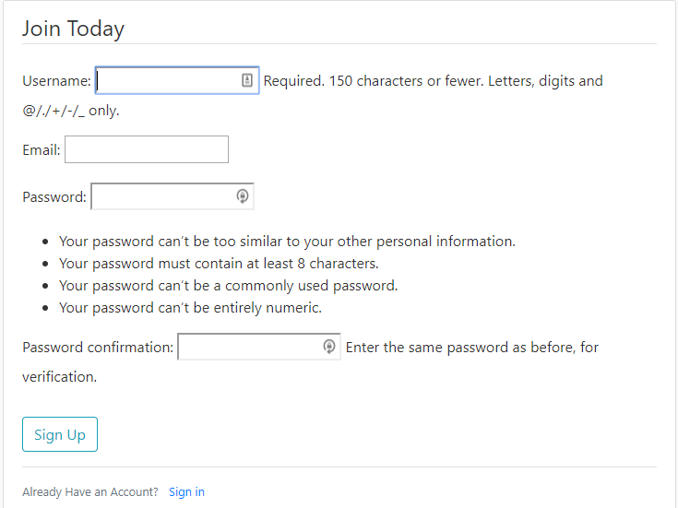

Now if create new user it should save it’s email address to our Users database.

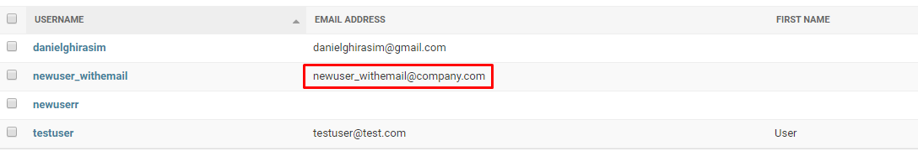

## Crispy Forms – Fixing our forms

We are going to use a 3rd party library in order to make our forms look nicer from within our register.html file. Crispy forms will do all the formatting for us and also will highlight the in red a field if something went wrong.

Crispy forms will style our forms in a bootstrap fashion.

1. Install crispy forms.

Pip install Django-crispy-forms

1. Once this is installed we need to tell Django that this is an installed app

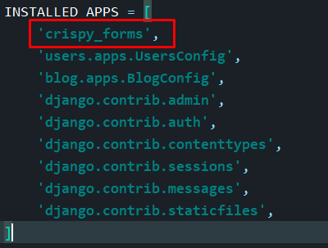

1. Then we are going to tell crispy forms which CSS framework we want to use. It defaults to BOOTSTRAP 2 but here we are using BOOTSTRAP 4. In order to do this we are going to scroll to the bottom of our settings page and add the following:

CRISPY_TEMPLATE_PACK = **'bootstrap4'**

1. Next we are going to load this into our template and use it. Open register.html

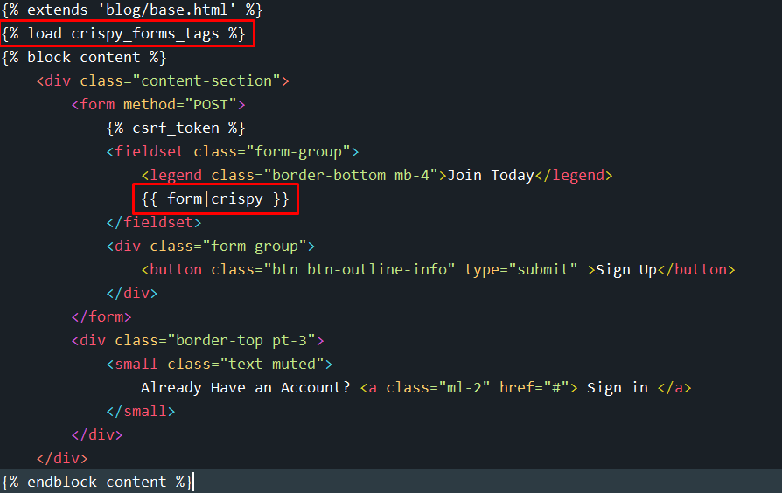

We have to add {% load crispy_forms %} just above our block content and modify our form.p variable to {{ form|crispy}} and if we save this we can see that our registration page looks very nice now.

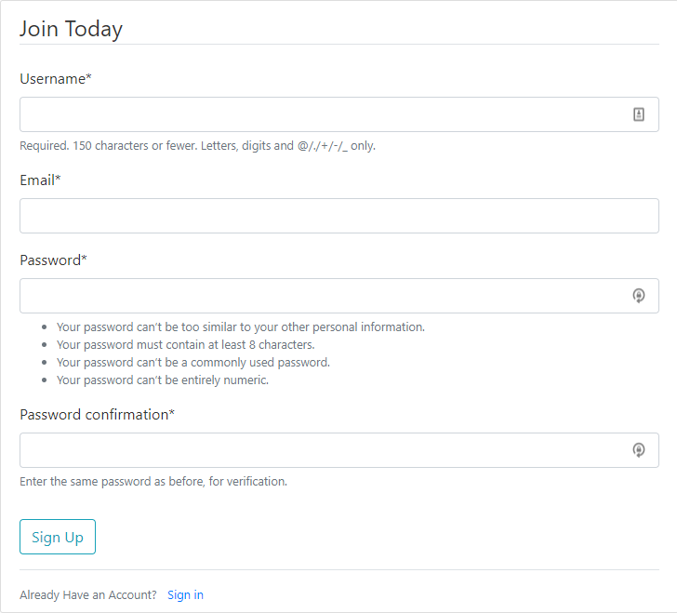

# Login-Logout System

Here we are going to design our login and logout functionality of our website. Luckily Django has most of this functionality taken care of by default.

We are going to start by importing Django’s default login and logout views into our main project urls.py module.

from django.contrib import admin  
from django.urls import path, include  
from users import views as user_views  
from django.contrib.auth import views as auth_views  
  
urlpatterns = **[** path**('admin/'**, admin.site.urls**)**,  
 path**('register/'**, user_views.register, name=**'register')**,  
 path**('login/'**, auth_views.LoginView.as_view**()**, name=**'login')**,  
 path**('logout/'**, auth_views.LogoutView.as_view**()**, name=**'logout')**,  
 path**(''**, include**('blog.urls'))**,  
**]**

LoginView and Logout View are classed based views. We haven’t seen these yet but will make some of our own later. These will handle the form and logic all for us but they won’t handle the templates. Now we are going to tell Django where to look for our login and logout template (by default it looks in a foldername registration/login.html and logout.html)

path**('login/'**, auth_views.LoginView.as_view**(**template_name=**'users/login.html')**, name=**'login')**,  
path**('logout/'**, auth_views.LogoutView.as_view**(**template_name=**'users/logout.html')**, name=**'logout')**,

Here we tell Django to look for the templates in the specified directory.

## Creating login.html and logout.html

The next step is creating our login and logout html files in users/templates/users/…

After we created this we are going to use a slightly modified version of our registration HTML.

### Login.html

{% extends 'blog/base.html' %}  
{% load crispy_forms_tags %}  
{% block content %}  
 **<**div class="content-section"**>  
 <**form method="POST"**>** {% csrf_token %}  
 **<**fieldset class="form-group"**>  
 <**legend class="border-bottom mb-4"**>**Login Page**</**legend**>** {{ form|crispy }}  
 **</**fieldset**>  
 <**div class="form-group"**>  
 <**button class="btn btn-outline-info" type="submit" **>**Login**</**button**>  
 </**div**>  
 </**form**>  
 <**div class="border-top pt-3"**>  
 <**small class="text-muted"**>** Do you want to create an account? **<**a class="ml-2" href="{% url 'register' %}"**>** Register **</**a**>  
 </**small**>  
 </**div**>  
 </**div**>**{% endblock content %}

We want to keep crispy forms in order to nicely format our login page and we modified some other stuff to properly represent a login page.

### Logout.html

{% extends 'blog/base.html' %}  
{% block content %}  
 **<**h1**>**You have been logged out.**</**h1**>  
 <**small class="text-muted"**>** Do you want to log back in? **<**a class="ml" href="{% url 'login' %}"**>** Login **</**a**>  
 </**small**>**{% endblock content %}

For now we removed the crispy forms part since we won’t be needing it here. Also we added a ‘Do you want to log back in part’ which redirects us to our login page.

### LOGIN REDIRECT to homepage and current issues

Next we are going to try to log in with our new login page but we will encounter an error.

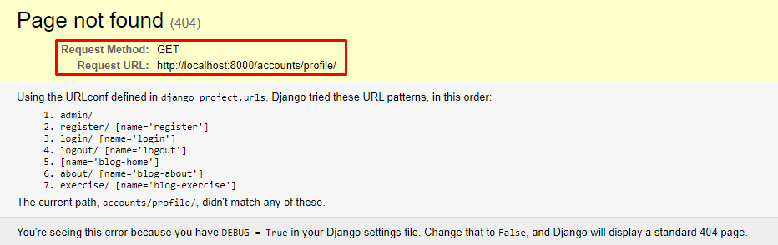

This is because when we log in, Django redirects us to it’s default url : website.com/accounts/profile. Currently we don’t have the profile part of our site setup right now so we are going to redirect the user to the home page.

How to fix.

We are going to open up our projects settings file and add the following.

LOGIN_REDIRECT_URL = **'blog-home'**

Now when we log in it will redirect us to blog-home (our homepage).

Now this is actually logging in our user to the website but we can’t see that yet because we don’t have any visual feedback setup yet. If you now navigate to website.com/admin it won’t prompt you a password.

## Redirecting Newly created users to login page.

Our current registration function is redirecting the users who have created a new account to the home page. We want to change this to redirect them to the login page because this will make more sense. To do that we are going to go back to our views.py and changes some stuff around.

def register**(**request**)**:  
 if request.method == **'POST'**:  
 form = UserRegisterForm**(**request.POST**)** if form.is_valid**()**:  
 form.save**()** username = form.cleaned_data.get**('username')** messages.success**(**request, **f'Account {**username**} created succesfully! You are now able to log in.')** return redirect**('login')** else:  
 form = UserRegisterForm**()** *# We are gonna make an instance for the class we just imported* return render**(**request, **'users/register.html'**, **{'form'**: form**})**

## Changing the Navbar for logged in users

We want to change our navigation bar in Django for authenticated and non authenticated users. The auth users shouldn’t see LOGIN and REGISTER navbars only something like PROFILE or LOGOUT.

Luckily this is very easy to implement in Django.

We are going to navigate to our base.html and modify some code.

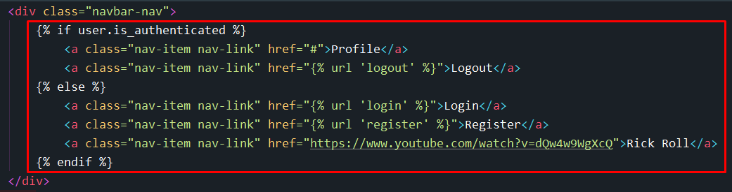

## How to put a restriction on certain routes first

The next thing we are going to do is put a restriction on certain routes so that you can only go to that site if you are currently logged in.

Ex.

Lets say you directly want to navigate to website.com/profile without being logged in. When a user does that and it’s not logged in we want to prompt a log in screen for that.

### Creating the profile.html page

We are going to head into our views.py module and make a new function that renders /profile/

def profile**(**request**)**:  
 return render**(**request, **'users/profile.html')**

Now we create the template for it.

Profile.html – we keep it simple for now

{% extends 'blog/base.html' %}  
{% block content %}  
 **<**h1**>**Current user {{ user.username }}**</**h1**>**{% endblock content %}

And let’s not forget to add the path to our urls.py module.

path**('profile/'**, user_views.profile, name=**'profile')**,

## Accessing profile only if user is logged in

With our current setup everyone can access website.com/profile/ and we want to make a setting in order to let only authenticated users to go to website.com/profile/ this is extremely easy to do in Django.

**To do this we are going to use a login required decorator that Django provides for us.**

**We are going to our users/views.py module , import the decorator and add that decorator to our profile staticmethod.**

from django.contrib.auth.decorators import login_required

@login_required  
def profile**(**request**)**:  
 return render**(**request, **'users/profile.html')**

# This doesn’t work for our classed based views, we are going to cover that later

**After doing this we are still getting an error if we try it out. It’s telling us that the page doesn’t exist.**

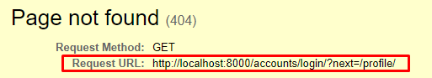

**Because Django looks for the route in a default location . So we need to tell Django where to find our login route and it’s as simple as going to the settings.py module, scroll to the end and add.**

LOGIN_URL = **'login'**

**We need to add this because we changed where our default login.html is.**

### **“?next=” in url**

When we got to website/profile.html without being logged in we are going to notice an added parameter in our URL.



**This is a Django feature. Basically this is keeping track of the page that we were trying to access and it will direct us to the page after the login. So after we log in we will be redirected to the profile page since that is the page we were trying to access.**

# Creating a User Profile and Picture

In this part we are going to create the part of our website that handles user profiles and pictures.

To start off we are going to head into users/models.py and we are going to extend the current User model that Django provides for us.

from django.db import models  
from django.contrib.auth.models import User  
  
class profile**(**models.Model**)**:  
 user = models.OneToOneField**(**User, on_delete=models.CASCADE**)** image = models.ImageField**(**default=**'default.jpg'**, upload_to=**'profile_pics')** def __str__**(**self**)**:  
 return **f'{**self.user.username**} Profile.'**

1.After importing User we are going to make a new class that inherits from models.Models

2.We are going to establish a one to one relationship with our User model with models.OneToOneField() which means:

One user can have on profile

And

One profile is associated with one user

We also add on_delete=models.CASCADE which deletes our profile picture if our user is deleted.

3.We are going to make a new variable called image that is equal to models.ImageField() . This is a Django build in model and the parameters we pass in are default=’default.jpeg’ which makes our default format a .jpg and upload_to=’foldername’ (this basically creates a folder for our profile pictures)

4.We add a __str__ dunder method so when run the print function on the profile it will return as the username.

**Now all we have left is to makemigrations in our commandline followed by python manage.py migrate.**

This will throw us an exception because we need another library called Pillow which handles our image manipulation. To do this we just have to type:

Pip install Pillow 🡪 after this the makemigrations and migrate command should work.

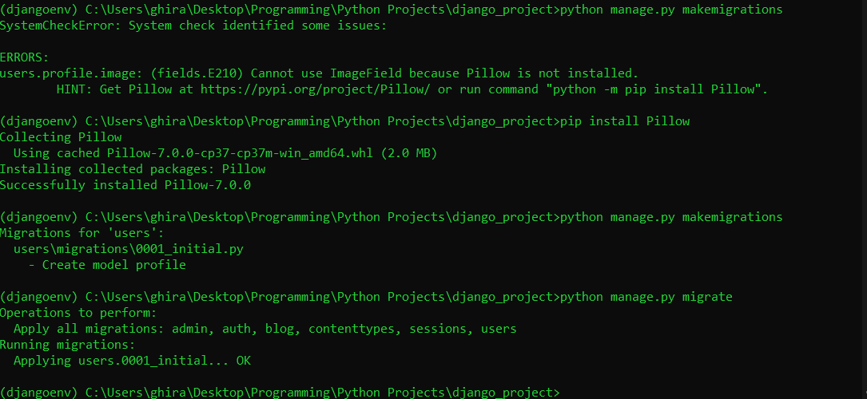

## Don’t forget to register this in our admins.py file

We are going to register our new Profile class in the admin.py file so we can access it trough the admin page.

And we went over this before but quick recap:

From .models import Profile

Admin.site.register(profile)

## Adding user profile pictures from admin page

Now we are going to navigate to our Django admin page select profile and add a picture to a profile. This isn’t gonna show yet because we don’t have the functionality implemented, but if you add a profile picture and go to python manage.py shell and import profile model then you can check that Django already uploaded the image to our website.

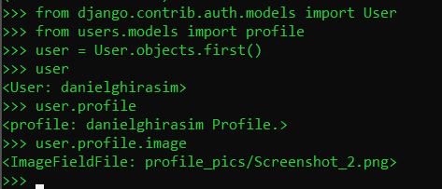

We can also access more attributes like:

Image.width

Image.height

Image.url

We are going to use the image.url in order to display the images in our website, because we are going to pass in the url location in our html file.

## Changing the location of the saved images

We want to change the location of where our images are saved in order to reduce clutter in our main Django folder.

In order to do this we are going to navigate to our settings.py folder and add a couple lines of code at the bottom.

MEDIA_ROOT = os.path.join**(**BASE_DIR, **'media')**MEDIA_URL = **'/media/**

This is basically telling that our MEDIA_ROOT is going to be /djangowebsite/media and MEDIA_URL is the public URL of that directory.

Further explained when we upload a profile picture then it is going to place a profile_pics folder inside the media folder within our root. This applies for future profiles.

## Displaying our profile.html properly

Next we are going to add some HTML code to our profile page in order to look nicer . This will include an image, email, username etc.

We are going to edit our profile.html with the following HTML code:

{% extends 'blog/base.html' %}  
{% block content %}  
**<**div class="content-section"**>  
 <**div class="media"**>  
 <**img class="rounded-circle account-img" src="userimage.jpg"**>  
 <**div class="media-body"**>  
 <**h2 class="account-heading"**>**Username**</**h2**>  
 <**p class="text-secondary"**>**username@email.com**</**p**>  
 </**div**>  
 </**div**>  
</**div**>**{% endblock content %}

We are going to modify this file further in order to make the images display.

{% extends 'blog/base.html' %}  
{% block content %}  
**<**div class="content-section"**>  
 <**div class="media"**>  
 <**img class="rounded-circle account-img" src="{{ user.profile.image.url }}"**>  
 <**div class="media-body"**>  
 <**h2 class="account-heading"**>**{{user.username}}**</**h2**>  
 <**p class="text-secondary"**>**{{user.email}}**</**p**>  
 </**div**>  
 </**div**>  
</**div**>**{% endblock content %}

We still have to do some more editing in our urls.py to make Django see our images.

Go to mainproject/urls.py and add the following

from django.contrib import admin  
from django.urls import path, include  
from users import views as user_views  
from django.contrib.auth import views as auth_views  
from django.conf import settings  
from django.conf.urls.static import static  
  
urlpatterns = **[** path**('admin/'**, admin.site.urls**)**,  
 path**('register/'**, user_views.register, name=**'register')**,  
 path**('login/'**, auth_views.LoginView.as_view**(**template_name=**'users/login.html')**, name=**'login')**,  
 path**('logout/'**, auth_views.LogoutView.as_view**(**template_name=**'users/logout.html')**, name=**'logout')**,  
 path**('profile/'**, user_views.profile, name=**'profile')**,  
 path**(''**, include**('blog.urls'))**,  
**]  
  
if settings.DEBUG:  
 urlpatterns += static(settings.MEDIA_URL, document_root=settings.MEDIA_ROOT)**